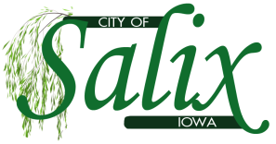

SALIX DRAINAGE MEETING AGENDA
Thursday, April 16, 2026
6:00pm

1) Call to Order
Roll Call: Gene Monk, Nick Black, Denise Burkhart, Emily Clayton, Brenda Smith-Hansen
2. Public Forum (Presentations under Public Forum shall be limited to five (5) minutes per individual or group)
3. Hold hearing on Classification Report for the Salix Drainage District
--V&K, Appointed Engineers, shall present the Classification Report filed February 2026 with the Salix Drainage District Trustees- (available on our website or at City Hall)
--Confirm Timely Publication and Service to Landowners (also available on our website or at City Hall)
--Review Written Comments or Objections Received
--Hear and Review Oral Comments or Objections
4. Close Hearing on classification for the Salix Drainage District
5. Review and Take Action on Written Comments or Objections Received
6. Review and Take Action on Classification Report (roll call)
7. Adjournment

