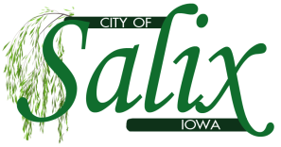

**SALIX DRAINAGE MEETING AGENDA**

**Thursday, July 31st, 2025**

**6:00pm**

**1)  Call to Order**

Roll Call:  Karen Allen, Nick Black, Denise Burkhart, Emily Clayton, Cindy VanAuken

**2. Public Forum**

**3. Hold hearing on Report of Repairs for the Salix Drainage District**

   --V&K, Appointed Engineers, shall present the [Report of Repairs](https://drive.google.com/open?id=1zCclHIdh6N380CE_Ulk-4Ku5p_Vi2bRI) filed June 2025 with the Salix Drainage    District Trustees- (available on our website or at City Hall)

     --Confirm Timely [Publication](https://docs.google.com/document/u/0/d/1Rbrzvylxkrp-l9JKm3XFmlbhcVtItzSV/edit) and Service to Landowners (*also* available on our website or at City Hall)

     --Review Written Comments or Objections Received

     --Hear and Review Oral Comments or Objections

**4. Close Hearing on repairs for the Salix Drainage District**

**5. Review and Take Action on Written Comments or Objections Received**

**6. Review and Take Action on Report of Repairs dated June 2025 from V&K**

**7. Adjournment**