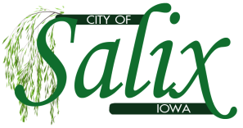
SALIX COUNCIL MEETING AGENDA

Wednesday, October 11, 2023

1) Mayor to call Council Meeting to Order
a. Roll Call: Karen Allen, Denise Burkhart, Emily Clayton, Donnie Nelson, Cindy VanAuken

2) Woodbury County Sheriff Department
a. Patrol Report

3) Oral requests and communications from the audience
a. Opportunity for citizens to address the Council. 5-minute time limitation

4) Resolutions and Ordinances
a. Resolution 2023-24, a resolution to name bank and maximum deposits (roll call vote)
5) Staff Reports
a. Review and approve financial report and claims (motion)
- Treasurer’s Report 2. Revenue Report 3. Expense Report
b. Review and approve water, sewer and maintenance reports.
- Water Loss Report 2. Water MOR 3. Wastewater MOR

6) Approval of Minutes
a. Approve minutes of September 13, 2023, council meeting (motion)

7) New Business
a. Dogs at Large Policy

8) Old Business
a. Nuisances Updates and approve acceleration of nuisance abatement procedures by filing of municipal infractions with city attorney (motion) Open Letters: 1 2 3 4 5 6
b. Drainage District Update

9) Messages from Mayor, Council and Staff
a.

10) Adjourn

